Union Incentives
CSEA.SBTA.CWA.POA
Managed
by
Employee Development
employeedevelopment@sbcusd.k12.ca.us
909.381.1169

Notes: Application will adjust as it is completed. The only attachments that are supported are PDF files.

Step 1: Click on the Laserfiche Link.

Step 2:Click the dropdown menu and select the appropriate application. See Figure 1.

Figure 1
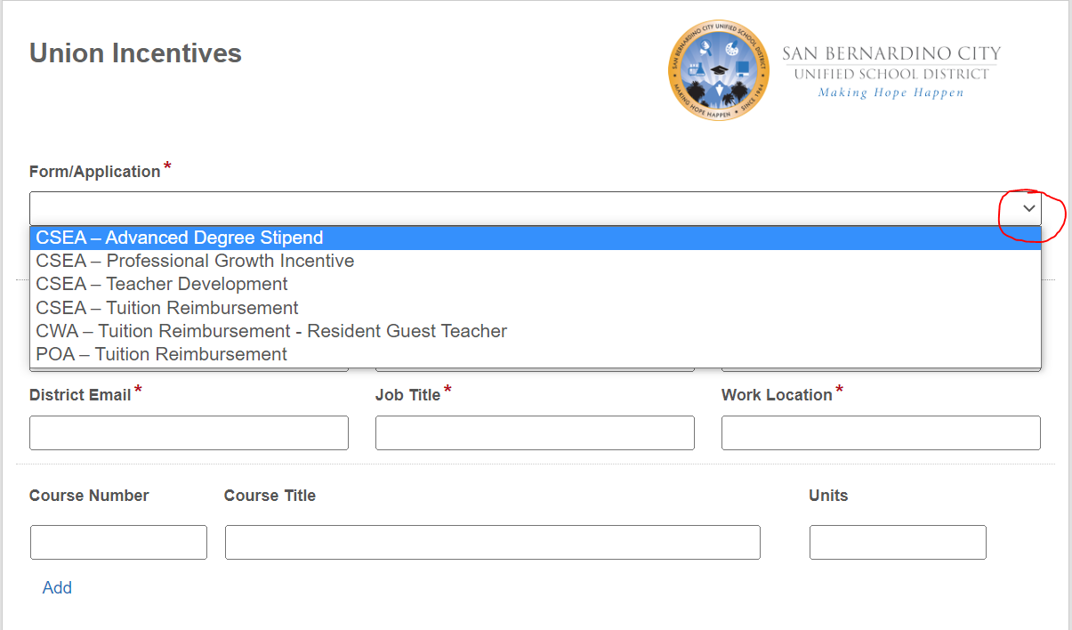

Step 3: Complete all required fields. For applications that require courses please press the “Add” button to create more course fields. See Figure 2.

Figure 2
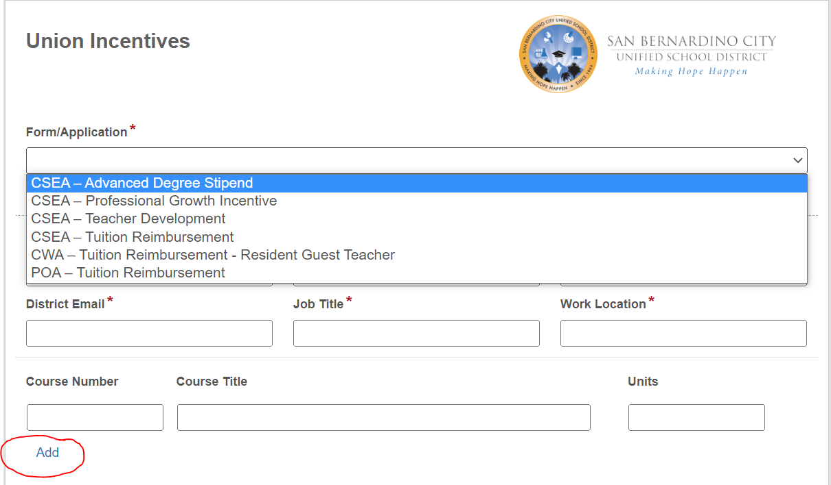

Step 4: Add only PDFs to the Upload field. Any other documents will not work. You can upload multiple attachments in the same field. See Figure 3. If you want to convert photos into PDF click here.
Figure 3
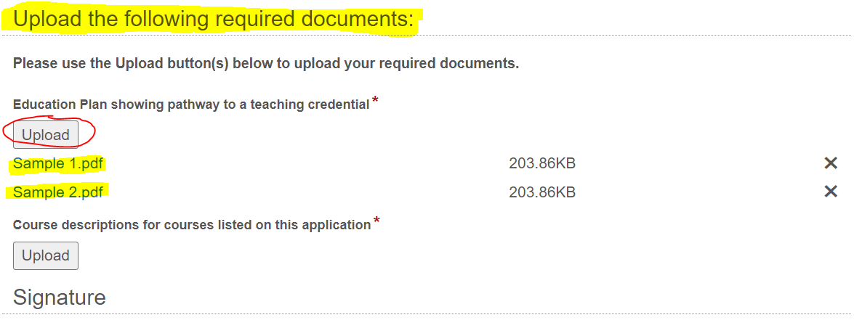

Step 5: You can sign your name by drawing it or typing it. See Figure 4.
Figure 4
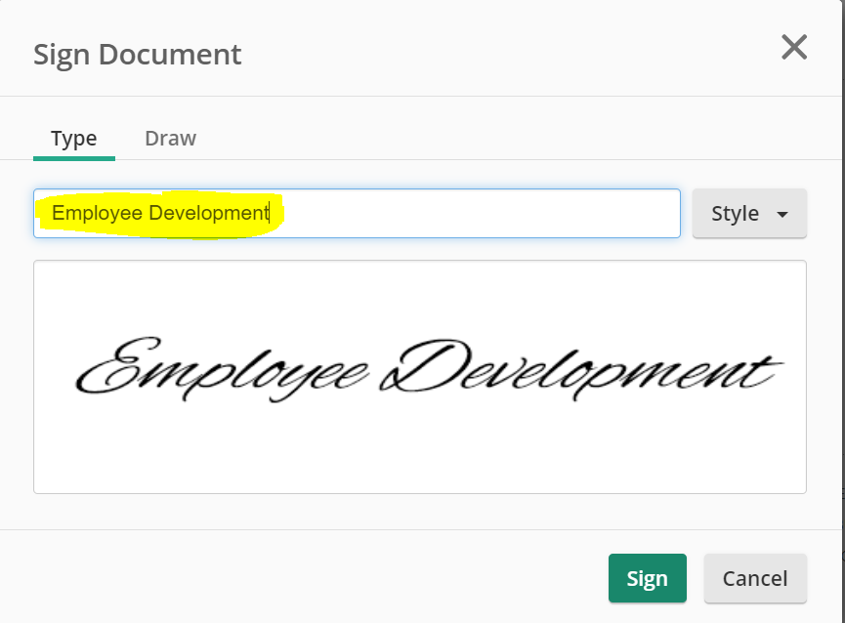

For more help contact Employee Development.

